|  |  |
| --- | --- |
| **University of Birmingham**  School of Engineering  **Department of Mechanical Engineering**  **Professional Laboratory Report**  **LI Mechanics 2** | |
| Surname | Chung |
| First Name(s) | Chi-Kin Ethan |
| ID number | 2160550 |
| Module Coordinator | **Dr. Aziza Mahomed** |
| Lab Coordinator | **Dr. Carol Kong** |
| Lab Code & Title | SM1003 – Unsymmetrical bending of a cantilever beam |
| Experiment Date & Time | 23/11/2021 |
| Lab Mech Group | 20B |
| Personal Tutor | Roger Dixon |
| Report Date | 06/01/2022 |
| Lab Report Title | Second moment of area of a cantilever beam undergoing unsymmetrical bending |

**Second moment of area of a cantilever beam undergoing unsymmetrical bending**

Abstract:

Beams usually consist of a symmetrical body and can be loaded in various ways that give the same second moment of area in that cross-section. If the beam does not have a symmetrical cross-section, the second moment of area for each side will vary. This experiment used an unsymmetrical beam loaded under different conditions at different orientations to see how this affects the beam and to see if theory and real life agree. From the results gathered, experimental and theory agree with less than 20% discrepancy between them, showing that the theoretical and experimental data agree. However, some areas could be improved upon to give more accurate and reliable results.

Introduction:

Beams are used in many industries to withstand a given load. Beams are usually loaded laterally and resist the load, thus holding it up. However, in certain circumstances, e.g., the structure was to be a certain shape whilst being light, a full symmetrical beam cannot or may not be used so an unsymmetrical beam would be used instead. In these cases, the second moment of area in the X and Y plane would differ as the load is not spread out equally across both planes. This difference increases when the beam is loaded at different angles. This inequality can lead to the beam to warp, bend and eventually break if large enough. The purpose of this experiment is to compare experimental second moment of area gathered in the lab to theoretical second moment of area calculated on paper.

Aims:

The aim is to see if the theoretical calculations for second moment of area match data gathered from real life.

Method:

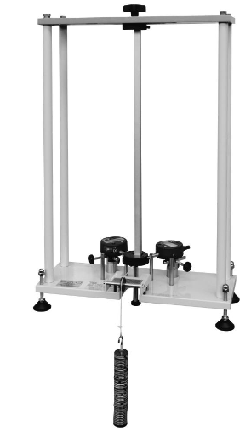

Handwheel

Unsymmetrical Beam

Weights on weight hanger

Digital indicator (Right Dial)

Digital indicator (left Dial)

Top Chuck (fixed to top plate)

Bottom Chuck

Top Plate

Sliding Pulley

Datum Pegs

*Figure 1: Apparatus used to gather data*

The unsymmetrical beam was placed into the top and bottom chuck and fastened in at 0° rotation and both digital indicators turned on. The datum pegs then were moved round to be in contact with the bottom chuck, the beam tapped to remove friction of the moving parts and a string laid over the pulley. Both dials were then zeroed and the numbers on the dials recorded. Then then beam was tapped again, and 0.1 kg made up of 0.01 kg weights were added to the string over the pulley and the reading on the dials recorded. This was repeated with 0.1 kg being added each time up to a maximum of 0.5 kg. The weights were then removed, the top chuck loosened slightly via the handwheel, and the beam rotated 22.5° clockwise. The handwheel was tighten again, the beam tapped to remove the friction again and the dials zeroed again. Readings were taken from 0 kg up to 0.5 kg using 0.1 kg intervals. This process was repeated until the angle of rotation reached 180°. U was then calculated using $\frac{left+right}{\sqrt{2}}$ and V was calculated using $\frac{left-right}{\sqrt{2}}$ for each head angle. The values of U and V for each head angle were plotted against the load mass and the gradient obtained. The gradients $\frac{dU}{dP}$ and $\frac{dV}{dP}$ were converted from mmg-1 to mN-1 and plotted against each other to give the graph in figure 1 in the shape of a Mohr’s circle.

Results:

*Table 1: gradients of U and V for each head angle in mmg-1 and mN-1.*

|  |  |  |  |
| --- | --- | --- | --- |
| dU/dP | dV/dP | dU/dP | dV/dP |
| mmg-1 | | mN-1 | |
| 0.0188 | -0.0069 | 0.001918367 | -0.0007 |
| 0.0249 | -0.0044 | 0.002540816 | -0.00045 |
| 0.0276 | 0.0011 | 0.002816327 | 0.000112 |
| 0.0225 | 0.0056 | 0.002295918 | 0.000571 |
| 0.0162 | 0.0074 | 0.001653061 | 0.000755 |
| 0.0093 | 0.0053 | 0.00094898 | 0.000541 |
| 0.0064 | 0.0002 | 0.000653061 | 2.04E-05 |
| 0.0083 | -0.005 | 0.000846939 | -0.00051 |
| 0.0135 | -0.007 | 0.001377551 | -0.00071 |

The gradients were found by plotting the U and V values at each head angle for each load mass value. The equation of the line was found, and the gradient obtained. These gradients were then converted from mmg-1 to mN-1 by dividing the value by 1000, then dividing that answer by 0.0098 (shown in table 1).

Plotted data

Mohr’s circle approximation used

Figure 1: graph of dU/dP against dV/dP with Mohr’s circle approximation.

As shown in the graph above, the plot of dU/dP against dV/dP vaguely resembles a circle with a few outlying points. A circle has been fitted to the graph as best as possible. The point plotted at (0.00282, 0.00011) is an outlier as it elongates the circular shape plotted by the other points. The centre of the circle (OC) was calculated as (0.0016, 0) m/N and the radius as 0.00098 m/N. Using the equations:

(Equation 1)

$$I_{x}=\frac{l^{3}}{3E\left(OC+R\right)}$$

$$I_{y}=\frac{l^{3}}{3E\left(OC-R\right)}$$

Equations 1&2: Equations used to calculate Ix and Iy

(Equation 2)

Where: L is length of specimen, 0.45 m

E is Young’s modulus of material, 69 GPa

OC is centre of circle (0.0016, 0)

R is radius of circle 0.00098

The values for Ix and Iy were 1.71 x10-10 mm4 and 7.10 x10-10 mm4 respectively.

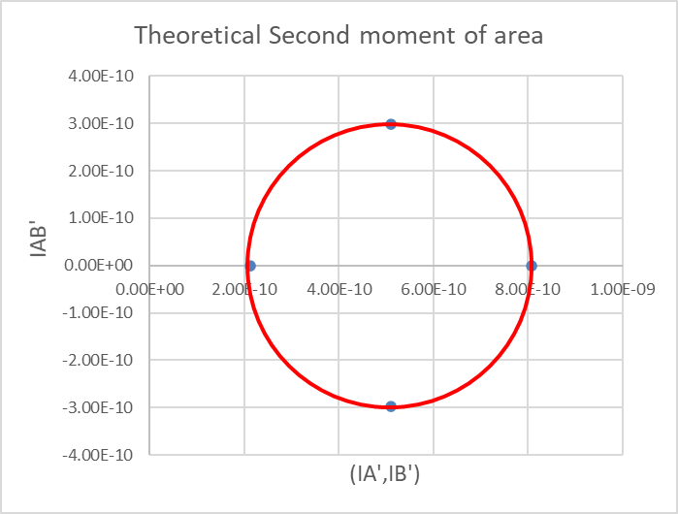

(5.10x10-10, 2.977x10-10)

(5.10x10-10, -2.977x10-10)

(0, 2.12x10-10) = Ix

(0, 8.077x10-10) = Iy

Figure 2: Mohr’s circle plotted to calculate the theoretical second moment of area

The theoretical data (shown in Figure 2) was obtained by finding the moment of inertia for the beam, then using parallel axis theorem to calculate the rotated moment of inertia. These points were then plotted to make a Mohr’s circle which was used to obtain Ix and Iy, with values of 2.12 x10-10 mm4 and 8.08 x10-10 mm4 respectively.

Discussion:

The Mohr’s circle plotted over the graph gathered did not encompass all data points but was placed in a position that covered the most points that fit the shape of a circle. This means values taken from the graph are estimates and contain errors. For a better representation, multiple readings for each head angles could be taken. This would allow an average to be taken so the results are closer to the true results.

The bar was tapped to remove any friction in the moving parts, if this was not done, this would add a systematic error to the readings as all the readings would include the friction. To improve, we should check at each reading that the bar was tapped to ensure that the frictional force was not considered in the readings.

The theoretical and experimental values had a difference of $\frac{\left(2.12*{10}^{-10}\right)-\left(1.71*{10}^{-10}\right)}{2.12*{10}^{10}}*100=19.34 \%$ and $\frac{\left(8.08*{10}^{-10}\right)-\left(7.10*{10}^{-10}\right)}{8.08*{10}^{10}}*100=12.13 \%$ for Ix and Iy respectively. This difference is relatively small meaning the values obtained from the experiment agree to the theoretical data calculated and can be considered accurate to a degree. To obtain more accurate readings, the experiment should be done multiple times so more data can be gathered and an average take. This would allow the experimental values to be closer to the true values.

The readings from the dial had an error of ±0.005. This means the percentage error was: $\frac{0.005}{0.19}*100=±2.63\%$. This percentage error is minimal, with such a low value, we can say the readings are accurate. This means that values of OC and R would also have a percentage error of ±2.63%. So the overall percentage error for Ix and Iy would be ±5.26%. This again is a small percentage error, so we can consider the Ix and Iy obtained through the experiment to be accurate.

Stacks of 0.01 kg weights were used to make up the 0.1 kg to 0.5 kg weights. If these weights did not weigh 0.01 g each, the actual weight would differ from the prescribed weight. The 0.01 kg weights had been used in previous experiments and could have been damaged before use in this experiment. If the weights had been previously dropped, knocked or chipped, this could alter the actual weight of each mass. If this had occurred multiple times, the actual weight of each 0.01 kg weight could have decreased noticeably. This in turn would lead to the experimental data to include a systematic error as the weight would not be that which was stated. To remove this possible systematic error, new weights could be used, multiple sets of weights used, or each weight measured before use. These would all decrease the chance of a systematic error.

Conclusion

It can be concluded that the experimental data does agree with the theorical calculations as there is only a maximum of 19.34 % discrepancy when measuring the second moment of area at a ±5.26% percentage error. This means that the data gathered is accurate and can be considered accurate. However, if these results were used for a building schematic the difference in values would be too significant to consider using the given beam in the circumstance. To decrease the difference, a stated before, the experiment could be done multiple times to gather an average value and to ensure all steps are followed correctly.